- In Power BI, use the FILTER() function to create a measure that counts the number of products in a Flipkart-style sales dataset where the rating is greater than 4.
ANSWERS:
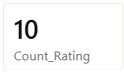
- Build a calculated measure using CALCULATE() and ALL() to show the overall average order value for all users in a Zomato orders dataset, ignoring any filters on city or cuisine.
ANSWERS:
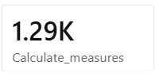
3.) Create a RANKX measure that ranks movies by total box office collection in a BookMyShow-style dataset and displays the rank next to each movie title.
ANSWERS:
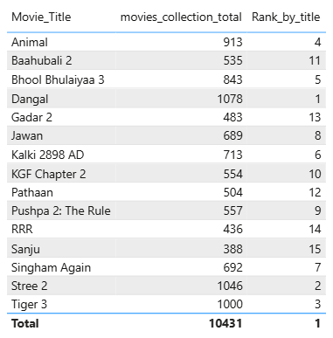

- Use the SUMX() function to calculate the total value of items in a Myntra shopping cart table, where each item has a quantity and price column.
Hint: SUMX() lets you multiply quantity by price for each row and then sum the results.
ANSWERS:

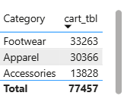

- With AVERAGEX(), build a measure that calculates the average rating per restaurant in a restaurant reviews table, and display it in a table visual in Power BI.
ANSWERS:
